Factor Analysis

Notes
Output Created |  | 28-JUN-2021 13:40:52
Comments
Input | Data | C:\Users\cpl\OneDrive\Desktop\EO Hackathon\EO Hackathon\USA\Climate Pillar\Z-score\z3.sav
Input | Active Dataset | DataSet37
Input | Filter | <none>
Input | Weight | <none>
Input | Split File | <none>
Input | N of Rows in Working Data File | 13
Missing Value Handling | Definition of Missing | MISSING=EXCLUDE: User-defined missing values are treated as missing.
Missing Value Handling | Cases Used | LISTWISE: Statistics are based on cases with no missing values for any variable used.
Syntax |  | FACTOR  /VARIABLES ZAir ZWater  /MISSING LISTWISE  /ANALYSIS ZAir ZWater  /PRINT UNIVARIATE INITIAL CORRELATION EXTRACTION ROTATION  /FORMAT SORT  /PLOT EIGEN  /CRITERIA FACTORS(2) ITERATE(25)  /EXTRACTION PC  /CRITERIA ITERATE(25)  /ROTATION VARIMAX  /METHOD=COVARIANCE.
Resources | Processor Time | 00:00:00.22
Resources | Elapsed Time | 00:00:00.21
Resources | Maximum Memory Required | 1176 (1.148K) bytes

[DataSet37] C:\Users\cpl\OneDrive\Desktop\EO Hackathon\EO Hackathon\USA\Climate Pillar\Z-score\z3.sav

Descriptive Statistics
 | Mean | Std. Deviation | Analysis N
ZAir | 1.2609 | 1.00000 | 12
ZWater | 1.3881 | 1.00000 | 12

Correlation Matrix
 |  | ZAir | ZWater
Correlation | ZAir | 1.000 | -.832
Correlation | ZWater | -.832 | 1.000

Communalities
 | Raw |  | Rescaled
 | Initial | Extraction | Initial | Extraction
ZAir | 1.000 | 1.000 | 1.000 | 1.000
ZWater | 1.000 | 1.000 | 1.000 | 1.000

Extraction Method: Principal Component Analysis.

Total Variance Explained
 | Component | Initial Eigenvaluesª |  |  | Extraction Sums of Squared Loadings
 | Component | Total | % of Variance | Cumulative % | Total | % of Variance
Raw | 1 | 1.832 | 91.578 | 91.578 | 1.832 | 91.578
Raw | 2 | .168 | 8.422 | 100.000 | .168 | 8.422
Rescaled | 1 | 1.832 | 91.578 | 91.578 | 1.832 | 91.578
Rescaled | 2 | .168 | 8.422 | 100.000 | .168 | 8.422

Total Variance Explained
 | Component | Extraction Sums of Squared Loadingsª | Rotation Sums of Squared Loadings
 | Component | Cumulative % | Total | % of Variance | Cumulative %
Raw | 1 | 91.578 | 1.000 | 50.000 | 50.000
Raw | 2 | 100.000 | 1.000 | 50.000 | 100.000
Rescaled | 1 | 91.578 | 1.000 | 50.000 | 50.000
Rescaled | 2 | 100.000 | 1.000 | 50.000 | 100.000

Extraction Method: Principal Component Analysis.
a. When analyzing a covariance matrix, the initial eigenvalues are the same across the raw and rescaled solution.

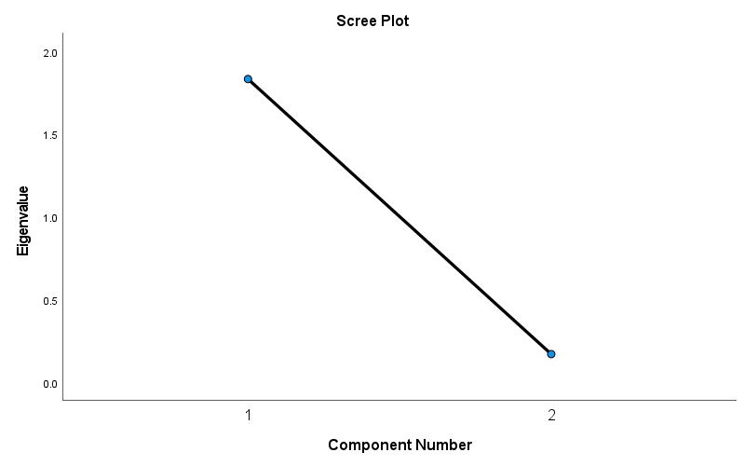

Component Matrixª
 | Raw |  | Rescaled
 | Component |  | Component
 | 1 | 2 | 1 | 2
ZAir | .957 | .290 | .957 | .290
ZWater | -.957 | .290 | -.957 | .290

Extraction Method: Principal Component Analysis.ª
a. 2 components extracted.

Rotated Component Matrixª
 | Raw |  | Rescaled
 | Component |  | Component
 | 1 | 2 | 1 | 2
ZWater | .882 | -.471 | .882 | -.471
ZAir | -.471 | .882 | -.471 | .882

Extraction Method: Principal Component Analysis.
Rotation Method: Varimax with Kaiser Normalization.ª
a. Rotation converged in 3 iterations.

Component Transformation Matrix
Component | 1 | 2
1 | -.707 | .707
2 | .707 | .707

Extraction Method: Principal Component Analysis.
Rotation Method: Varimax with Kaiser Normalization.

